**Lesson02 Deploying Azure VM service**

**Notes:-**

**1-with virtual machine service the underline physical structure is fully controlled by Azure**

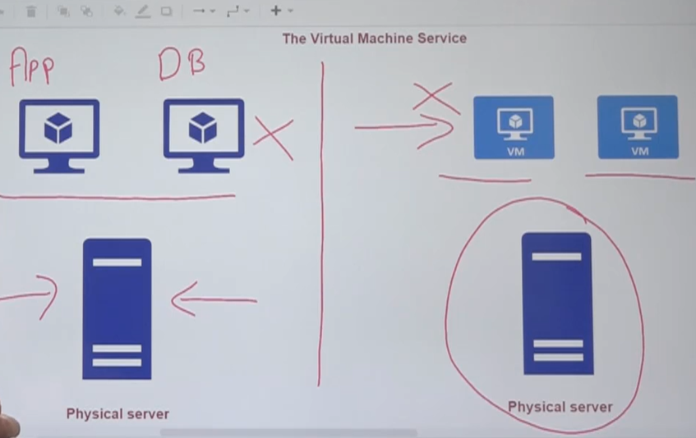

**2-when you deploy virtual machine you need to create the following resources**

**A-Virtual Network**

**B-Network Interface**

**C-Private IP Address**

**D-Public IP Address**

**E-The disks**

**F-NSG (network security group)**

**3-resource group is used to logical resource grouping of resources**

**Steps:-**

**1-on azure portal 🡪 create new resources**

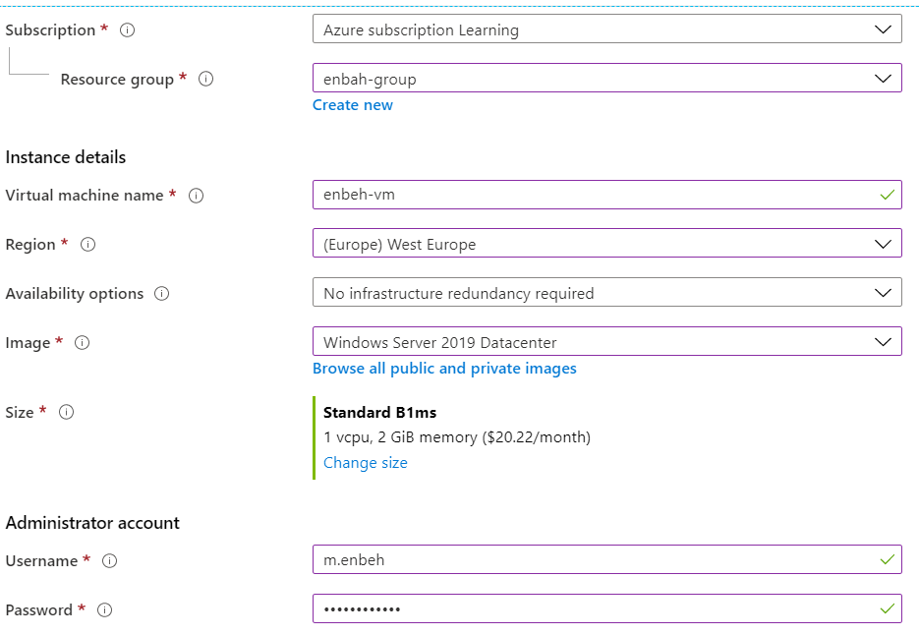

**We see that B1ms has 1 virtual CPU and 2 GB Ram and capability to contain 2 data disk but by default it will create 1 O.S with ability to add 1 Data disk**

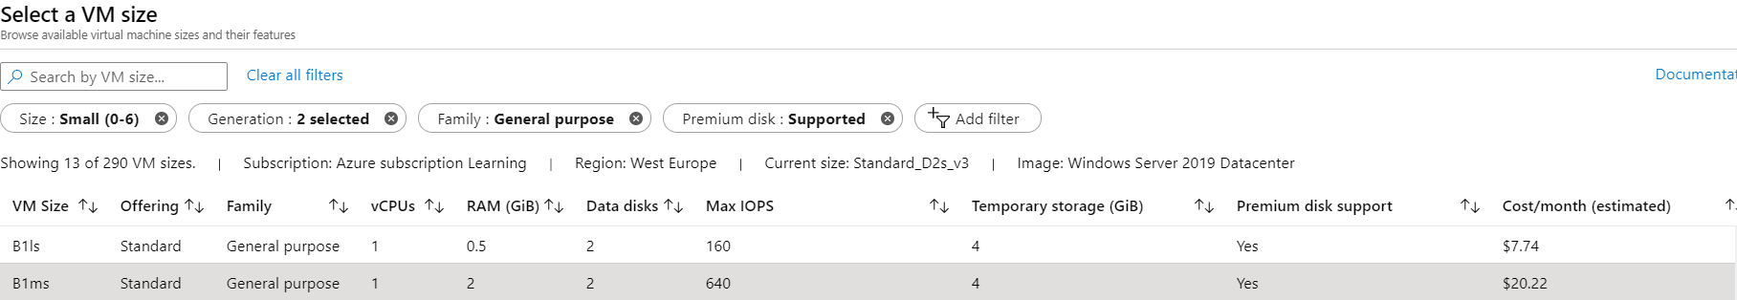

**2-on Disk tab we see that we choose standard SSD disk with ability to add data disk**

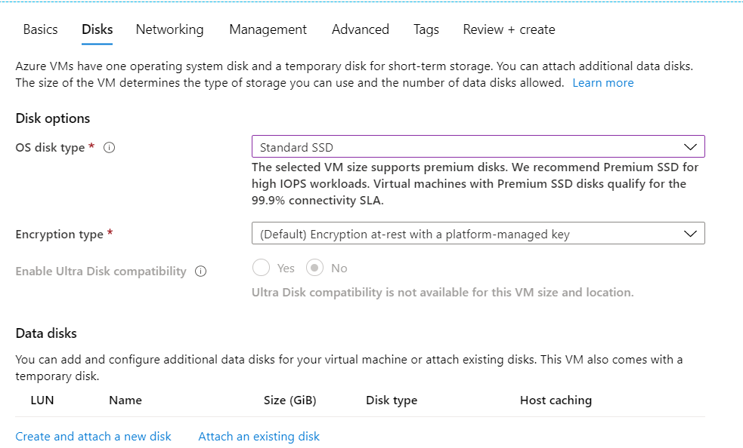

**3-on Networking tab we see that it asks you to add Azure network, and Network with public and private IP address**

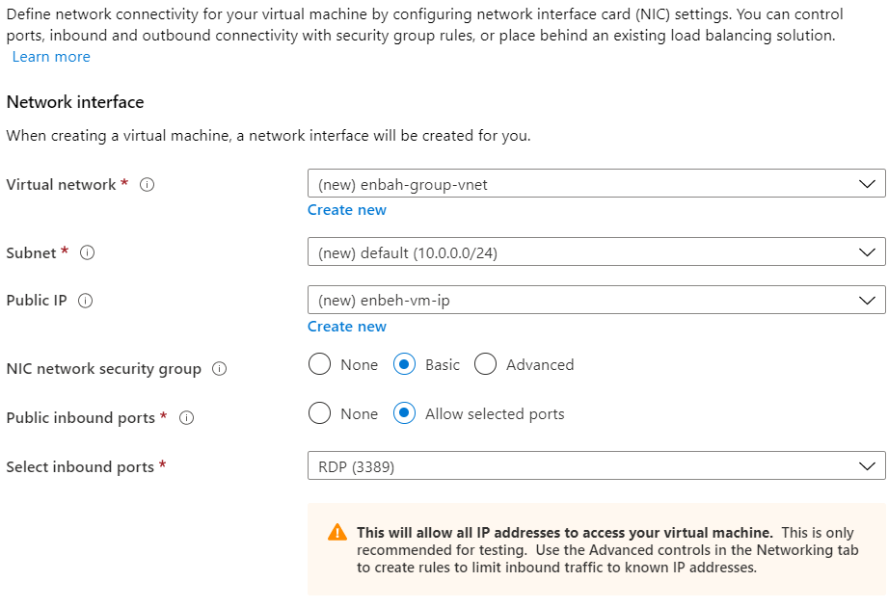

**4-on management tab we see that we have the option to add the ability to write diagnostic problems on VM to storage account**

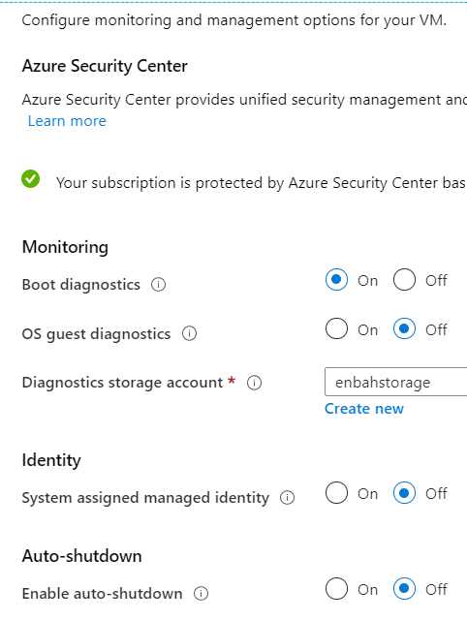

**5-on Tags tab, you will see that you can add / remove resource that will created with the Azure VM service which is 7 resources**

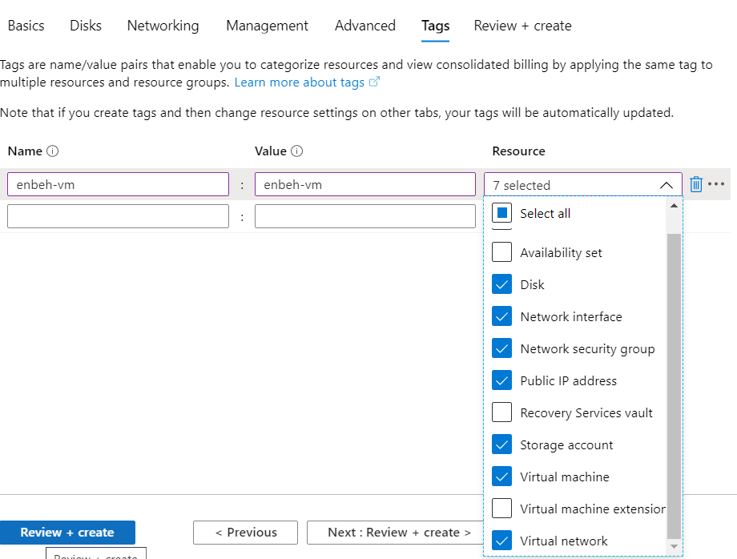

**(The Resources created with the Azure VM service)**

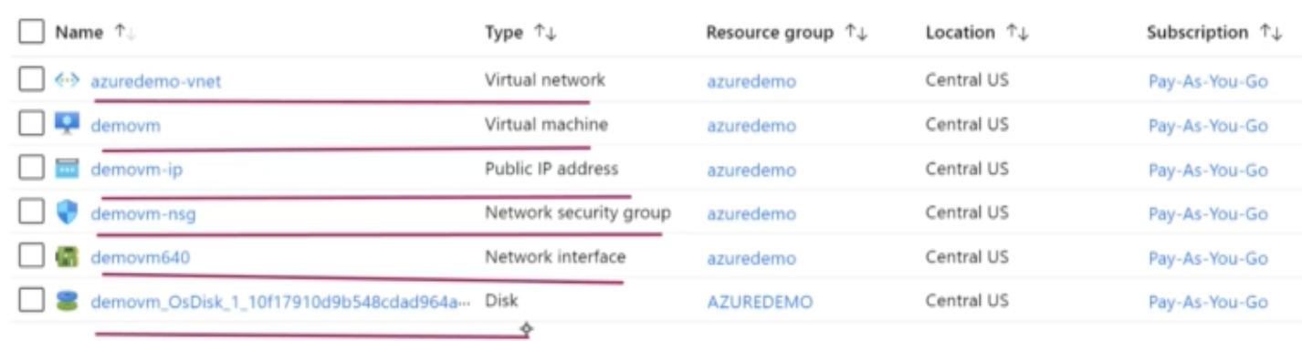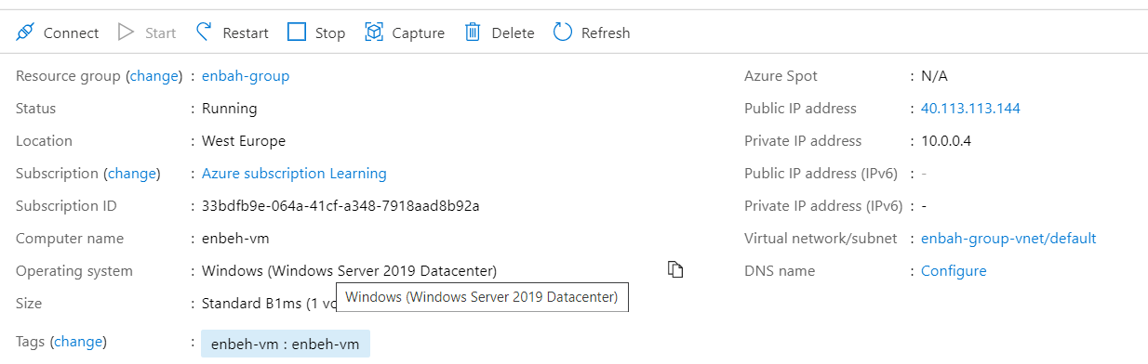

**Section02 More Details about Azure VM**

**Notes:-**

**1-on the Azure VM create you will see it will show details such as resource group, status, Location, Subscription, etc.…**

**(You will see that I create the VM on the same resource group and subscription)**

